The amount of blood flowing through a blood vessel can be regulated by contraction or relaxation of smooth muscle in the
A. tunica intima
B. tunica media
C. tunica adventitia
D. all of these
ANSWER: B
__________is the narrowing of blood vessels
A. vasoconstriction
B. vasodilation
C. hypertension
D. hypotension
ANSWER: A
___________is the widening of your blood vessels
A. vasoconstriction
B. vasodilation
C. hypertension
D. hypotension
ANSWER: B
Blood circulation is also controlled by _________acting on arterioles
A. hormones
B. vasoconstriction agents
C. both a and b
D. none of these
ANSWER: C
__________is an especially powerful vasoconstriction hormone, and epinephrine is less.
A. TSH
B. Norepinephrine
C. FSH
D. LH
ANSWER: B
Substance called _________can cause powerful vasodilation are formed in the blood and tissue fluids of some organs. e.g histamine
A. kinins
B. vasodilator agents
C. both a and b
D. none of these
ANSWER: C
The ______________carry oxygenated blood except pulmonary artery
A. Arteries
B. Veins
C. Capillaries
D. None of these
ANSWER: A
The ___________ carry deoxygenated blood except pulmonary vein
A. Arteries
B. Veins
C. Capillaries
D. None of these
ANSWER: B
____________are normally either completely open or completely closed, and the degree of constriction of the metarteriole also varies.
A. Precapillary sphincters
B. sphincters
C. Anal sphincters
D. Tubues
ANSWER: A
___________a sphincter of smooth muscle tissue located at the arterial end of a capillary and serving to control the flow of blood to the tissues
A. Precapillary sphincters
B. sphincters
C. Anal sphincters
D. Tubues
ANSWER: A
Most of the prostaglandins are
A. effective
B. Not affective
C. vasodilator agents
D. none
ANSWER: C
Vasodilators
A. dilate blood vessels
B. reduces the volume or space inside affected blood vessels.
C. both a and b
D. none
ANSWER: A
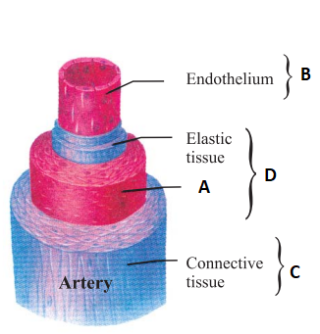
What does B represent in the given diagram?
A. Tunica intima
B. Tunica media
C. Tunica adventitia
D. skeletal muscle
ANSWER: A
_____________are thick walled vessels
A. Arteries
B. Veins
C. Capillaries
D. None of these
ANSWER: A
____________are thin walled blood vessels

A. Arteries
B. Veins
C. Capillaries
D. Both B and C
ANSWER: D

